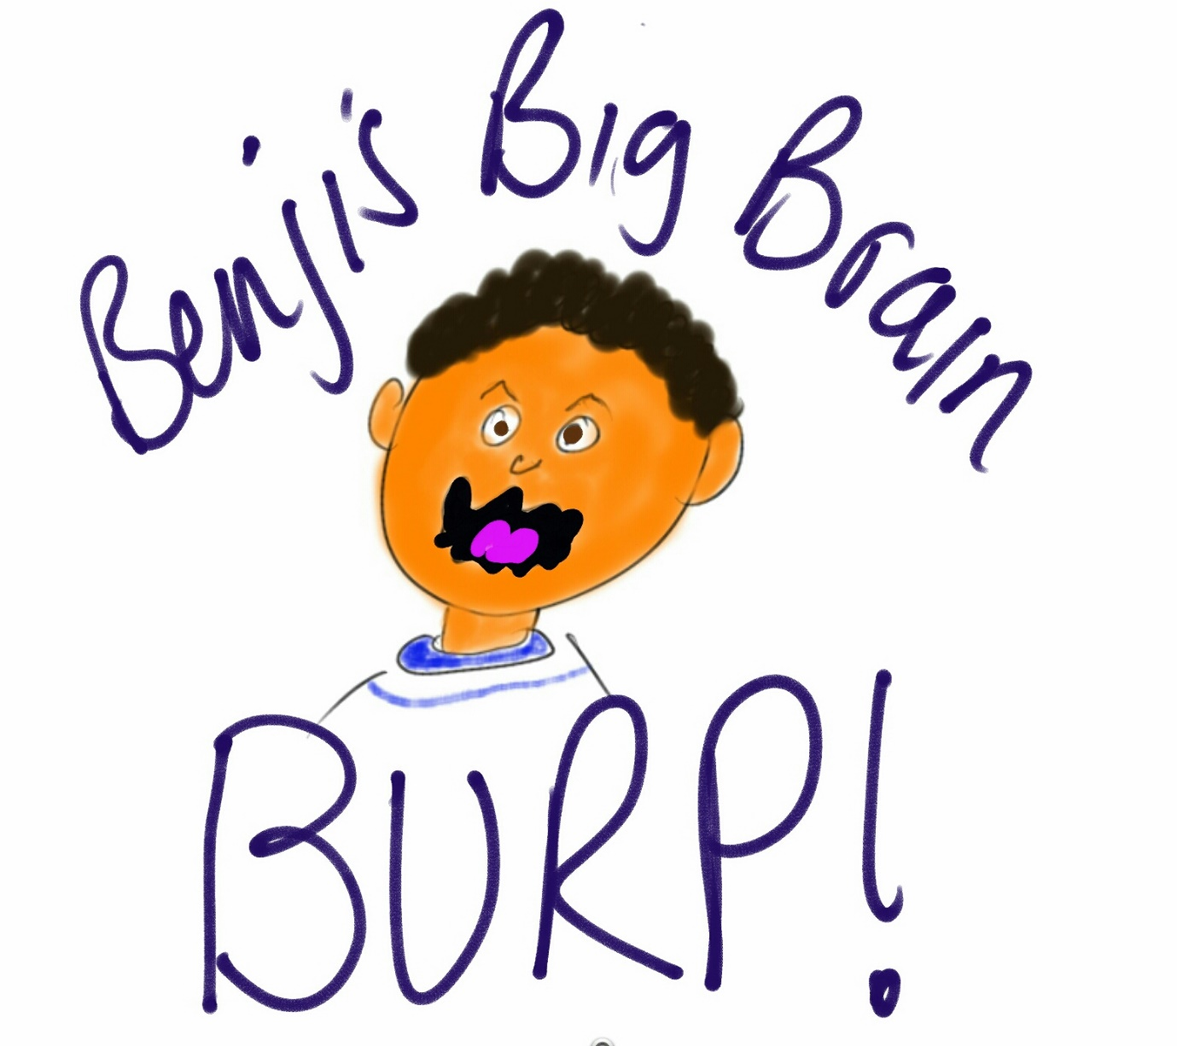

Benji’s Big Brain Burps.
By Russell Hurn © 2019

Slurrrrp! Tomato sauce splashed on Benji’s chin as he sucked in the last wriggly piece of spaghetti before pushing his plate away.

(Picture Benji slurping spaghetti)

He was stuffed. Spaghetti was his favourite meal but after slurping and sucking his way through two bowls of mum’s special recipe he was now beginning to feel it was too much. His tummy had come to the same conclusion too and was making all sorts of strange noises, making him wriggle uncomfortably on his seat.

Burrp! Buurrrrrrp!

(Picture Benji wriggling and burping)

“Benji!” mum shouted, “Sorry mum” he replied with an embarrassed rosy glow on his cheeks “I think I’ve had too much to eat, my tummy feels funny”.
“I’m not surprised”, mum replied “You’ll feel better in a bit. Your tummy just needs more time to sort out all that dinner”.

(Picture Benji going to bed)

Later Benji was tucked up in bed, he’d brushed his teeth, washed his face and had his story. It was time for sleep but although he was tired he was not sleepy, well at least his brain wasn’t.

In fact, Benji’s brain had all of a sudden seemed to wake up and was very busy indeed.

(Picture series Benji in bed with monster thoughts around him eating thoughts of football and handstands)

Benji hated this time of the day. He tried to think of playing football with dad or how to do a handstand but thoughts he didn’t want seemed to keep popping into his head. The thoughts were like little monsters they would hide in the shadows in the day and at night time, when it was dark, they would jump out frightening him and eating up the nice things he tried to think of. Benji’s tummy began to hurt but it wasn’t the spaghetti this time; he was scared.

“Mummmm!” Benji cried out as loud as he could, so mum was sure to hear him over the noise from her TV programme. The familiar sound of mum’s footsteps on the stairs made Benji feel better almost instantly as the scary thoughts ran back into the shadows of his bedroom.
“What’s up sunshine? Is your tummy still feeling funny?” Mum said, as she popped her head around the door.
“Yeah, well,sort of”.
Mum came and sat on the bed, putting her warm hand on Benji’s forehead.

(Picture, mum sat on the bed, monsters hiding)

“Is it those thoughts about what happened?” Benji nodded, he didn’t like to talk about it because he was afraid mum would remember and get upset too; so he tried to smile but it was one of those smiles that don’t really make anyone feel happy.

“I think it’s time to get some help” mum said before she snuggled up close. The last thing Benji thought of before drifting off to sleep was mum dressed as a super hero chasing the monsters from his room.

(Picture, superhero mum)

The next day mum took Benji to the doctors. The lady they spoke too had a nice smile, she listened carefully when mum spoke about the things that had happened, Benji looked embarrassed as she mentioned his scared thoughts at night and the bad dreams.

(Picture talking to therapist)

When mum finished the lady thought for a while, smiled again and said “ Benji, I think you’re having some brain burps” She noticed the strange look on Benji’s face as his nose and forehead wrinkled to show his confusion.

“When something really bad happens that is so scary it stops our brains making a normal memory so the bad bits keep coming back, like burps”.
“I did a big burp yesterday didn’t I mum” Benji said with a big, ‘I’m clever’ kind of smile.
“Yes you did right after your double helping of my spaghetti” mum laughed.
“Well” the lady continued, “it sounds like the spaghetti was too much for your tummy and it’s like that for the brain, some bad things can be too much”.
Benji was imagining his brain being full of spaghetti.

(Picture Benji’s spaghetti brain)
( Picture series happy memories and neat cupboard where everything is stored)

The lady waited for Benji to be listening again and said “When we have good things happen, like birthday parties or holidays our brains notice all the things we see and hear and smell, then because we enjoyed them we talk about it. We tell our family and friends and this helps to sort it out into a normal memory which the brain keeps safe, like putting something away neatly in a cupboard”.

Benji was trying to imagine a neat cupboard, his one in his bedroom was not neat at all. Every time he opened the door something would fall out, at the moment he knew an action man leg was stuck in the door where it had tried to fall out this morning and he had closed the door quick.
(Picture of messy toy cupboard)

The lady seemed to notice Benji thinking “have you got a nice neat cupboard Benji?” Mum laughed.

“When we have bad things happen to us the things we see, and hear, and smell maybe so horrible we don’t talk about them. We try to stop ourselves thinking about them, but this doesn’t work they just keep coming back, like things falling out of a messy cupboard.” Benji was thinking maybe this lady was a spy or something because how could she know about his messy cupboard.

Smiling she continued “Your brain needs to sort out those nasty memories but really just wants to hide them all away, but that doesn’t work and they pop up again and again as”, she hesitated for a moment and they said “brain burps”.

Benji smiled, he liked this lady and it was funny hearing a grown up saying ‘burps’.

“So what we need to do to help you feel better is find ways to help you think about what happened in a way that is not scary. Then your brain can sort the memory out and put it away neatly, so no more burps. Just coming here today is the start of that. All the way home Benji’s brain was burping, it burped up pictures, and sounds and even smells about what happened. He told mum and she listened to his burps. Thank you for telling me Benji, she smiled.

That night Benji was awake again. He had a dream. A large ugly monster was eating his mum’s special recipe spaghetti. Every mouthful it took it got bigger, but not in a scary way it just seemed to get bigger like a balloon, and then with a final mouthful the monster balloon flew off around the room making a very rude noise indeed. As it flew is got smaller and smaller and eventually flew out of the room. Benji woke “Muuuummm!” when mum came in she looked calm she sat on the bed and with a smile in her voice said “brain burps Benji?” When they stopped laughing they talked about what had happened.

(Picture Benji laughing and monsters backing away)

Benji went back to see the lady at the doctors a few more times. Sometimes they chatted, sometimes they drew, sometimes they played, sometimes mum joined in and they talked about the thing that happened.

Benji soon noticed that he wasn’t worried about telling mum about his scary brain burps anymore as she didn’t get upset.

The bad thoughts at night got less and less and so did the bad dreams. It was like the monsters weren’t scary anymore.

Benji even learned some new things about what happened, he learned how brave he had been and how it wasn’t his fault. When he thought of the monsters now, he felt much bigger than them. He imagined being a tough police officer catching the monsters and sending them to jail.

(Picture monsters in jail).

Benji still has a messy cupboard in his bedroom but his brain has managed to put his bad memory away neatly, so no more burps. When Benji goes to sleep now his brain is happy thinking about handstands, chocolate cake and playing football with dad.

